(The answers have been reviewed and approved by Dr. Dina)

Features

Q1)
$e = 0.3 , p = 0.8, s = 1 (Translational model)$

$N > \frac{log( 1- p)}{log(1 - (1 - e)^{s})}$

$N > \frac{log( 1- 0.8)}{log(1 - (1 - 0.3)^{1})}$ , $N > 1.33 , N ≈2$

Q2)
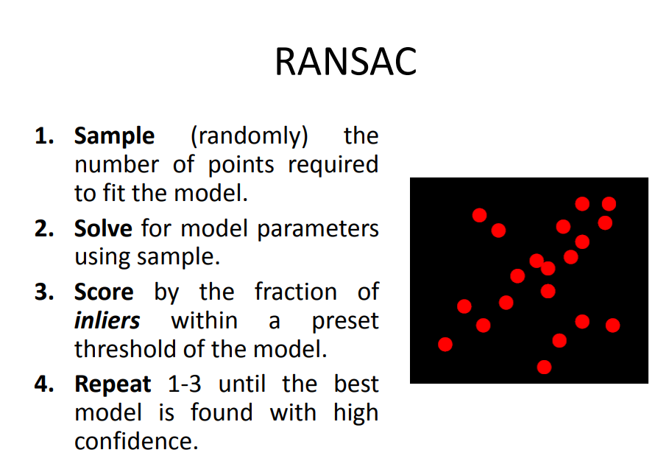
(lec 6, slide 24)

Q3)

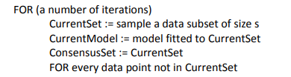
if distance(CurrentModel, datapoint) < t:
add to ConsensusSet
END FOR

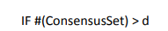
RETURN CurrentModel
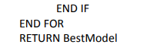

Q4)
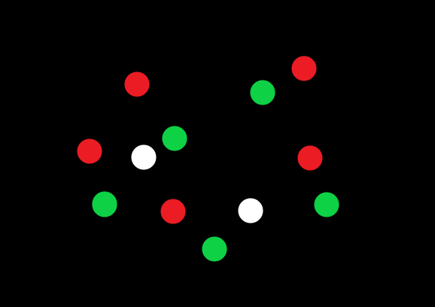
let $C_{R}$ be the camera that sees Red and $C_{G}$ be the Camera that sees Green

$C_{R}$ view:  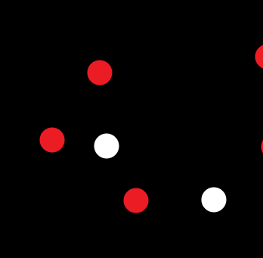 | $C_{G}$ view: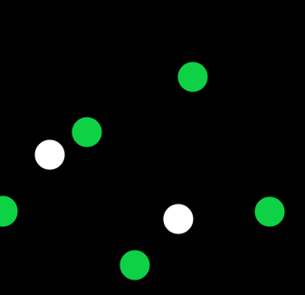
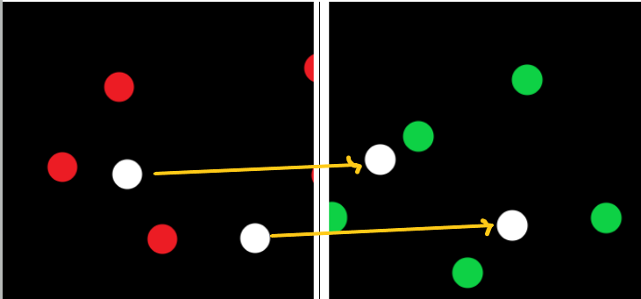
i.
$C_{R}$ : sees 5 red points and 2 White points
$C_{G}$ : sees 5 green points and 2 White points
ii.
Yes, Since we have 2 points which are visible to both cameras (white points) so we can get 2 matches which is sufficient for estimating a homography matrix of translation that contains only 2 unknowns

iii.
The RANSAC algorithm

Algorithm:  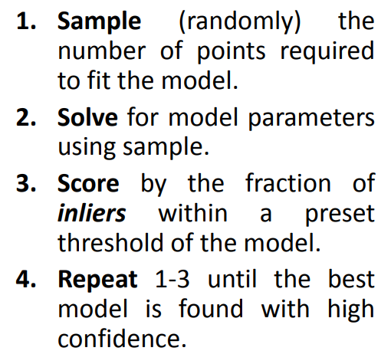 | Parameters:  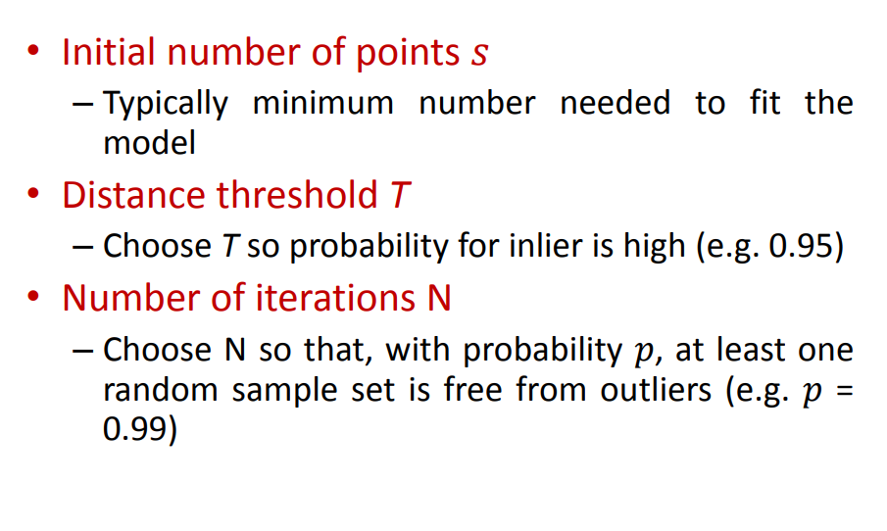

Q5)
- From all the photos (including your photo):
  - Extract the features of the photo using SIFT
  - Learn “visual vocabulary”
  - Quantize features using visual vocabulary
  - Represent photos by frequencies of “visual words”
  - Convert each histogram into a normalized feature vector
- Use a k-NN model to list the top images matching your template image based on a similarity(distance) metric
- If the image distance is less than a certain threshold:
  - Add the photo to the subset of images which you appear in

Object Recognition

Q1)
i. Histogram of hues (colors) can be used as features for image
ii.
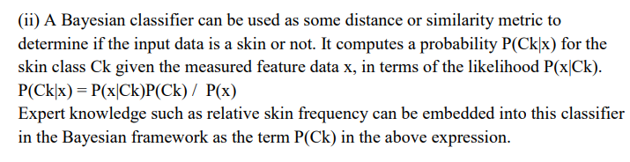
(Final 17 answers)

Q2)
A model that can be used is Naive Bayes as follows:

- Extract Features $x$ from images (e.g. Color histogram)
- Calculate $p(B | x) = p(x | B) p(B)$ where $B$ represents the $Background$
- Calculate $p(F | x) = p(x | F) p(F)$ where $F$ represents the $Foreground$
- Classify the pixel as $B$ if $p(B| x) >p(F|x)$

Q3)
The BoW represents each image as a vector containing the count of appearances of predetermined Visual Words
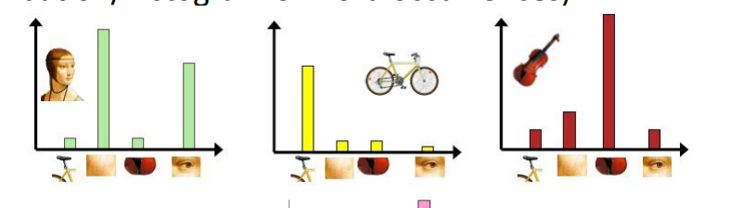
a Visual Word is a subpart of an image that can be used as a feature to represent that image. Also, it’s the center of a K-means cluster representing the mean of all features in that cluster.

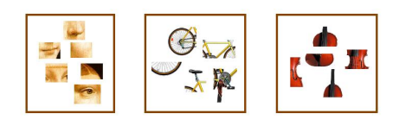
The BoW can be used in object recognition as follows:
- Extract Features
- Learn “visual vocabulary”
- Quantize features using visual vocabulary
- Represent images by frequencies of “visual words”
- Convert each histogram into a normalized feature vector
- Use a classifier (k-NN or SVM) to classify images from the feature vectors

Q4)
Architecture:
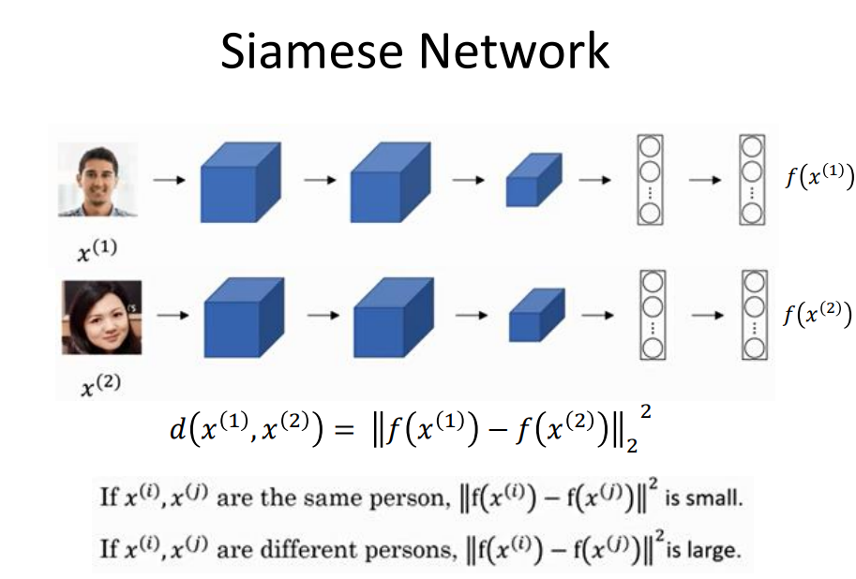(Lec 8, Slide 48)
Learning Procedure:
- Input: Triplets of an anchor image (training image), a positive image (image from the same class as anchor) and a negative image (image from a different class than the anchor)
- Learning Objective: Minimize distance between anchor and positive images and maximize distance between anchor and negative images
- Loss Function: Triplet loss
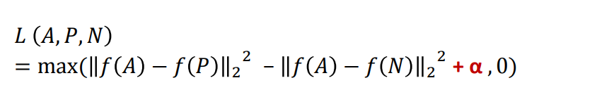

Q5)
i.
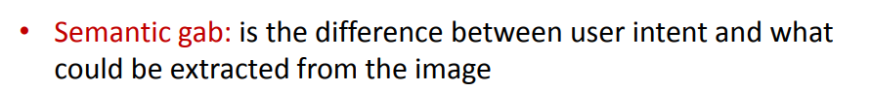_{(Lec 8, slide 35)}

ii.
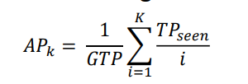
• $k = 6$ (results count)
• $GTP = 3$ (Total positives (cat images) in database. given in question)

Model 1:

$AP_{6} = \frac{1}{3} ( \frac{1}{1} + \frac{0}{2} + \frac{0}{3} + \frac{2}{4} + \frac{3}{5} + \frac{0}{6} =0.7$

Model 2:

$AP_{6} = \frac{1}{3} ( \frac{1}{1} + \frac{2}{2} + \frac{3}{3} + \frac{0}{4} + \frac{0}{5} + \frac{0}{6} =1$

The second model is more accurate.

Q6)
same as Q4

Object Detection

Q1)

i.

 | R - CNN | Fast R-CNN | Faster R-CNN
Method of Region Proposals | Selective Search | Selective Search | Region Proposal Network
Number of ConvNets | 2000 ConvNet | 1 ConvNet | 1 ConvNet
Object Classification Function | SVM | Softmax | Softmax
Speed | Slow (2000 forward passes for each image) | Fast | Faster

ii.
- Divide image into a grid, then use multiple boxes for each grid cell to reach a final bounding box with the predicted class and confidence
- Since multiple boxes with different sizes are used for each cell the algorithm can overcome the size variations of objects
- By using Non-Max Suppression only the predictions with the highest confidence are used, so each pedestrian will have a single bounding box
- Since the algorithm predicts a class for each pixel then multiple pedestrians can be detected with no problems

Q2)

i.
ROI pooling layer is used to resize/wrap the region proposals to a fixed size

ii.
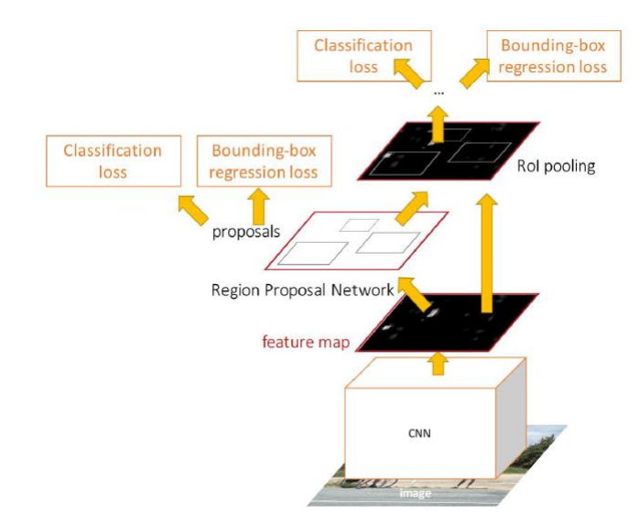

iii.
Instead of using Selective search the Faster-RCNN uses a Region Proposal Network to learn RoI’s

Q3)

- Since the R-CNN selects 2000 regions then uses 2000 ConvNets for predictions
- Fast R-CNN, because it replaced the 2000 ConvNets with 1 ConvNet

  - For each cell in the feature map, use k windows around it and make predictions for each window
  - sort windows by the largest predicted confidence that an object exists in that window
  - then take the largest n windows with the highest confidence as region proposals
- $Output = (S×S × (5 ×B + C)$ , where:
• $S×S =$The size of the grid (number of anchor)
$• 5 =$$dx, dy, dw, dh, Confidence$ (The bounding box attributes and Confidence)
• $B =$The window/box count around each anchor
• $C =$Class probabilities
- $Output = (S×S × (B ×(5+ C))$ , where:
Each anchor box has it’s class probabilities

Image Segmentation

Q1
i. Semantic Image Segmentation
ii. Deconvolution Network for Semantic Segmentation
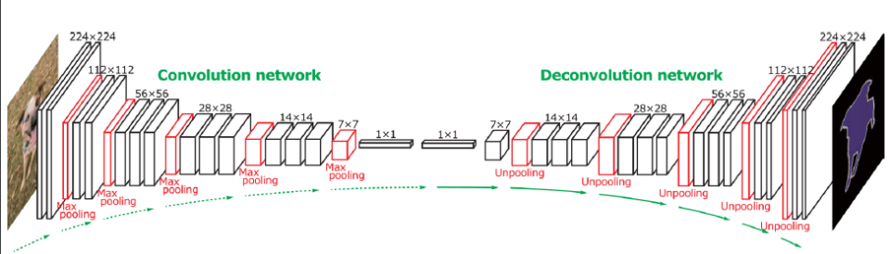
Input: an image
Output: A Map containing the class of each pixel of the input image

iii. Instance Image Segmentation
iv. The target image should be labeled such that the objects each have a bounding box

Q2)

i.
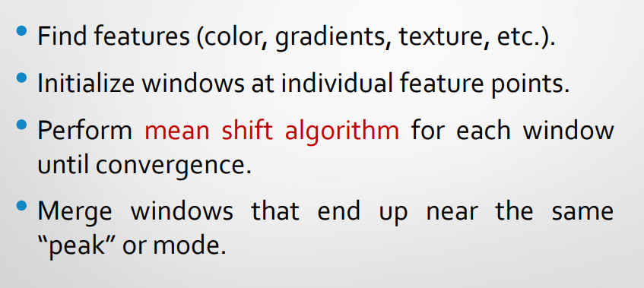
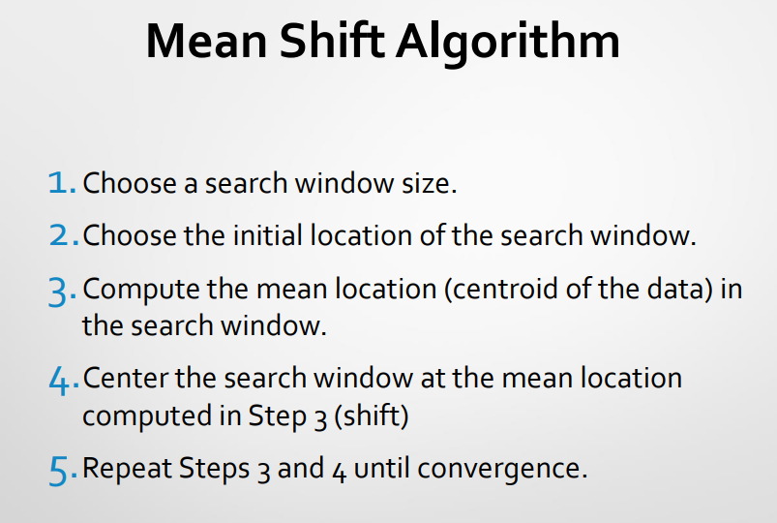
Parameters:
• Windows size

ii.
• Very large window size is fast but not accurate and can lead to mistakenly segmenting of multiple objects as one object
• small window size is slower but more accurate but very small size can lead to noise being detected as an object

iii.
- Doesn’t assume a shape of the clusters (K-means assumes spherical clusters)
- Not Sensitive to outliers
- Find variable number of clusters (no prior knowledge of the count of objects is needed)

Q3)
The task can be done using a Mask R-CNN network
